CelcomDigi Mega Add-ons
1. Launch Details
Key Summary USP | Mega Add-Ons - Enjoy premium benefits at the best value on top of your existing Postpaid plan.
Channels | - CelcomDigi App  - MSA  - Pulse

2. Product or Campaign Details
Offering Details | Below are the offers under CelcomDigi Mega Add-Ons: -  Offer Plans Eligibility Price  Disney+ Basic + 5GB CD60 SE – CD100 RM12.90/month RRP:RM29.90  CD120 – CD190 RM3.90/month RRP:RM29.90  Disney+ Premium +5GB​ CD60 SE – CD100 RM27.90/month RRP:RM49.90  CD120 – CD190 RM9.90/month RRP:RM49.90  Prime Video + 5GB​ CD60 SE – CD100 RM13.00/month RRP:RM25.00  CD120 – CD140 RM4.00/month RRP:RM25.00  Viu Premium + 5GB CD60 SE – CD80 RM3.90/month RRP:RM21.90  CD160 RM0.90/month RRP:RM21.90  Sooka Premium​ (Mobile & TV) + 5GB CD60 SE – CD100 RM34.90/month RRP:RM44.10  CD120 - CD190 RM15.90/month RRP:RM44.10  Sooka Sports & Entertainment (Mobile) + 5GB CD60 SE – CD100 RM17.90/month RRP:RM26.10  CD120 - CD190 RM8.90/month RRP:RM26.10  Sooka Entertainment+ ​(Mobile & TV) + 5GB CD60 SE – CD100 RM15.90/month RRP:RM28.00  CD120 - CD190 RM6.90/month RRP:RM28.00  Sooka Entertainment (Mobile) + 5GB CD60 SE – CD100 RM5.90/month RRP:RM13.90  CD120 - CD190 RM1.90/month RRP:RM13.90  MobileSHIELD 1 Device CD60 SE – CD100 RM4.00/month RRP:RM10.00  CD120 – CD One Pro RM1.00/month RRP:RM10.00  MobileSHIELD 5 Device CD60 SE – CD100 RM7.00/month RRP:RM15.00  CD120 – CD One Pro RM3.00/month RRP:RM15.00  Roaming Internet Singapore | Indonesia | Thailand 30GB + 15 Minutes​ CD60 SE – CD100 RM30.00/month RRP:RM118.00  CD120 and above RM20.00/month RRP:RM118.00  Roaming Internet Worldwide (95 countries) 80GB + 15 Minutes​ CD60 SE – CD100 RM60/month RRP:RM118.00  CD120 and above RM35/month RRP:RM118.00  Note:  - All MEGA Add-Ons come with a 12-month service contract.  - There will not be any auto-renewals after the 12-month period ends.

3. Eligibility and Criteria
Eligibility & Criteria | New & Existing Postpaid customer

4. Customer Journey (current journey / campaign only)
Customer Journey | Customer who purchased via CelcomDigi app:​  - Targeted CelcomDigi customers will receive SMS to check out Roam Pass offers via CelcomDigi app.​  - SMS: CelcomDigi customer will launch the CelcomDigi app. Check out banner at the Main top / Roaming section.​  - PN: CelcomDigi customer will launch the CelcomDigi app and land to the Roaming section.​  - Eligible customer will be able to see the Below the Line (BTL) offers banner and choose the Singapore, Indonesia, Thailand (SIT) pass which will lead to the listing page in Freedom Add-Ons to view offer details.​  - Upon pressing Confirm CTA, CelcomDigi customer will land on Order Confirmation screen. ​  - An SMS will be sent to the customer upon successful Roam pass activation.  Box of Surprise (BOS) Display in CelcomDigi app (Main Top & Roaming zone)  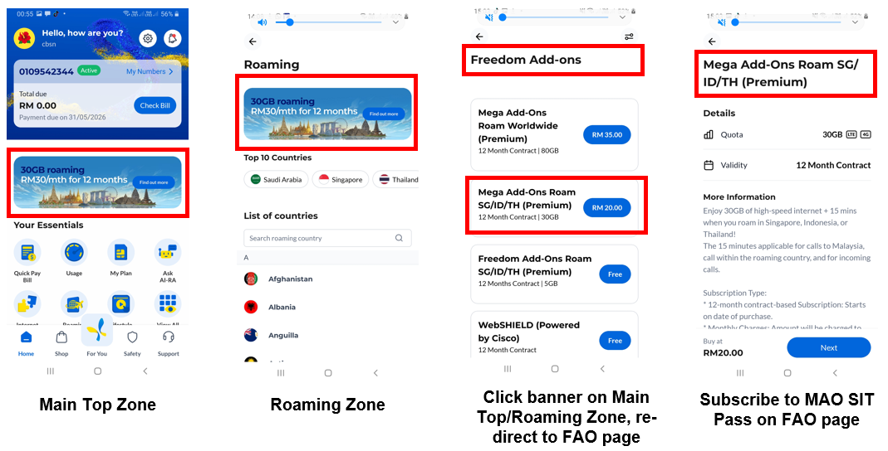

5. Customer Communications (Active)
FAQs | Eng: https://help.celcomdigi.com/en/support/solutions/folders/70000487828  BM: https://bantuan.celcomdigi.com/support/solutions/folders/70000487833

6. Internal Information
Visuals | NA

7. Reference Guide (Agent Guide, Scenario Handling and Other References)
Reference Guide | NA

8. Historical Communications (no longer active but retained for reference only)
Inactive Comms | NA

